A113 PARTNERS
VISION 2100
A BLUEPRINT FOR HUMANITY
EXECUTIVE SUMMARY
The Foundational Vision, Strategic Agenda, and Long-Term Global Development Framework of Ambassador Ivonne A-Baki
Ambassador Ivonne A-Baki
Foundational Vision and Leadership Principles
William Michael Hadala Jr.
Principal Strategic and Technical Architect
A113 Partners
Strategic Research, Architecture, and Publication Development
FIRST EDITION · NOVEMBER 2026 · ENDORSED FOR PUBLICATION BY AMBASSADOR IVONNE A-BAKI

EXECUTIVE SUMMARY

Vision 2100 at a Glance
VISION 2100 IN ONE SENTENCE
Vision 2100 proposes one evidence-gated system — clean power, sovereign compute, honest institutions, productive jobs, prevention and peace — that sovereign nations can begin building now, with existing mandates, existing institutions and five modest pilots, and that stops anything that does not work.

ENDORSEMENT
Ambassador Ivonne A-Baki reviewed Vision 2100 — A Blueprint for Humanity and endorsed it for publication on 2 November 2026. The book's technical, economic, geopolitical and implementation recommendations are those of A113 Partners. No government, United Nations body or other institution has adopted or agreed to any proposal in it.

About Vision 2100
Vision 2100 — A Blueprint for Humanity sets out how a world of shared prosperity, sovereignty and peace could be built between 2026 and 2100, and how every step could be measured. For each subject it answers five questions: where the world stands today; what it should look like in 2100; how to get from here to there; what must begin immediately; and how progress will be measured, with baselines, milestones, owners, risks and corrective actions.
The book is published by A113 Partners, with William Michael Hadala Jr. as Principal Strategic and Technical Architect. Its foundation is the set of leadership principles Ambassador Ivonne A-Baki has stated in public. Its technical, economic, geopolitical and implementation recommendations are those of A113 Partners, not hers. It is written to stand on its own whether or not she becomes Secretary-General, and its recommendations are addressed to whoever holds that office, to member states, to regional institutions, to development banks and investors, and to the public.
In this summary, proposals are written as proposals ("Vision 2100 proposes…"); statements by the Ambassador are marked as documented; and scenarios, archetypes and cost ranges are marked illustrative. Facts are sourced in the parts of the book shown in brackets, and the principal sources are listed at the end.

The foundation: principles the Ambassador has stated
◆ DOCUMENTED POSITION In her interactive dialogue with the UN General Assembly on 20 August 2026, Ambassador A-Baki distinguished a manager, who follows a mission statement, from a leader, who follows a north star, and described her north star for the Organization as renewal rather than reform. She said a Secretary-General should be on the ground in war zones and areas of tension, and that "the good offices of the Secretary-General should also be the active offices." She described peace negotiations as still dominated by men, recalled that she was the only woman at the table in the Ecuador–Peru negotiations, and said women and children suffer most from war (Parts I and VIII).
◆ DOCUMENTED POSITION She described the shortfall on the Sustainable Development Goals as a failure of financial execution rather than of ambition, called for an end to new layers of debt on the Global South, suggested debt swaps for education and health, and named corruption as a reason developing countries lack resources. She said what the Organization lacks is trust in results, and that when member states trust the UN, financing follows. She called for the UN to serve as the universal negotiating table at which every nation, large and small, helps set ethical, fair and binding guardrails for artificial intelligence (Parts I, IX and X).
Vision 2100 builds on these principles. She did not propose the programs, pilots or institutions described below in her dialogue; they were developed by A113 Partners, and she endorsed Vision 2100 for publication on 2 November 2026.

The case for action
The world is more capable and more fractured than at any time in living memory. There were 65 state-based armed conflicts in 2025, the most since records began in 1946, and world military spending reached about $2.9 trillion. Some 117.8 million people were forcibly displaced at the end of 2025 (Part I).
Human development has stalled. About 831 million people lived in extreme poverty in 2025, and in fragile and conflict-affected economies the rate has not fallen in fifteen years. Some 655 million people lack electricity and about 645 million faced chronic hunger in 2025. About 3.7 billion people lived in 2023 in countries that spend more on interest than on health or education (Parts I and X).
The century's defining capability is concentrated. In 2025 only 32 countries hosted specialized AI data centers, and about 2.2 billion people remained offline. Data-center electricity use, about 415 terawatt-hours in 2024, is projected by the International Energy Agency to more than double by 2030 in its base case (Parts I, IV and V).
The institutions meant to manage these pressures are weakened. The UN's 2026 regular budget of $3.45 billion reflects cuts of about 15 percent in resources and about 19 percent in staffing, and in January 2026 the Secretary-General warned of a risk of imminent financial collapse (Parts I and III).
Cooperation still works when it is designed well. Smallpox was eradicated by Cold War rivals working together; the ozone layer is recovering under the Montreal Protocol; under-five deaths fell by more than 60 percent between 1990 and 2023. Vision 2100 adopts the conditions those successes shared — narrow, verifiable tasks; measurable targets; cheap, proven interventions; joint monitoring — as its design rules (Parts I and II).
The next five years decide much of the century. About 1.2 billion young people will reach working age over the next decade, against about 420 million projected jobs. Member states have already adopted the mandates on which to build: the Pact for the Future and Global Digital Compact (2024), resolution 79/325 on AI governance (2025) and the UN80 mandate-review resolution (2026). The Global Dialogue on AI Governance meets in New York on 3–4 May 2027 (Parts II, III and XII).

One integrated system
Vision 2100 proposes one system, not a list of separate policies. Reliable, clean electricity makes computing and industry possible. Computing, carried to every citizen by connectivity, makes modern education, health care and accountable government possible. Capable government enables productive industry and jobs. Jobs give people dignity and a stake in stability. Stability lets diplomacy succeed, and peace protects the investments that sustain energy and industry (Part XII).
FIGURE ES-1
The Vision 2100 system: each link enables the next
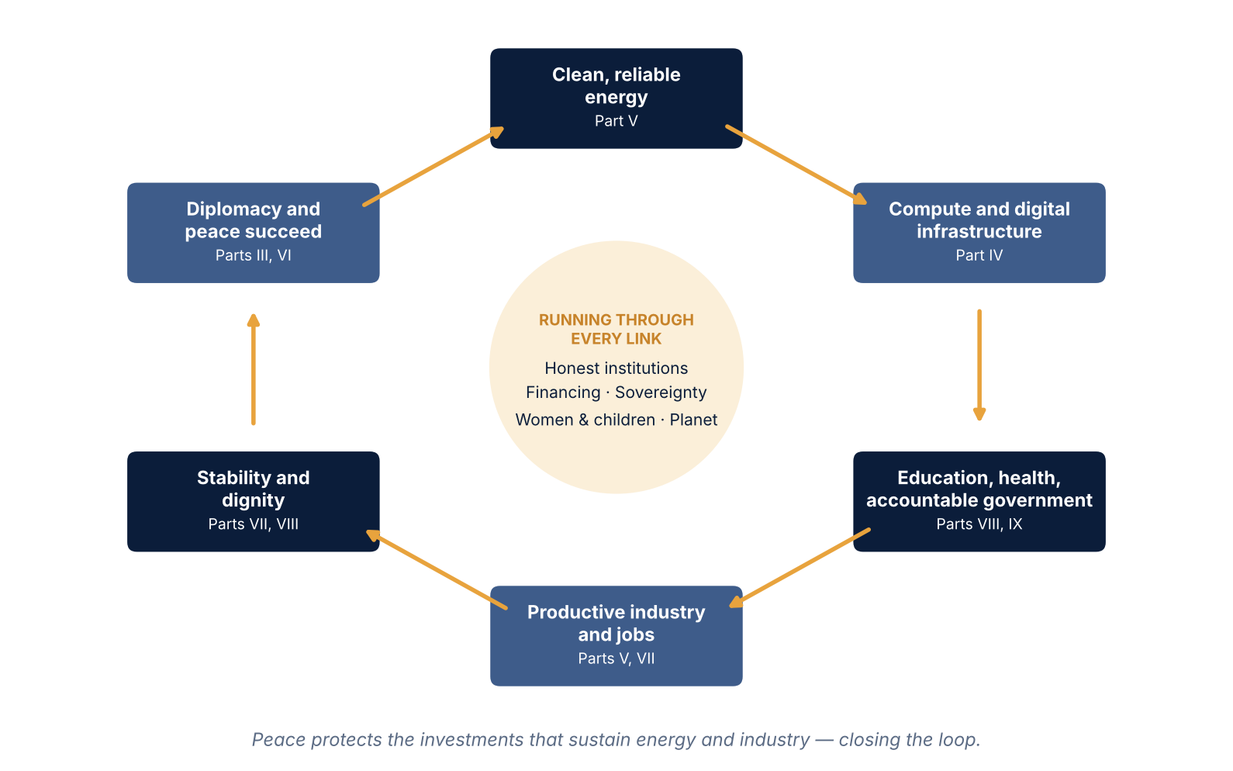
Conceptual model developed for Vision 2100 by A113 Partners.
Five threads run through every link: honest institutions that make public money verifiable; financing matched to purpose; national sovereignty over resources, data and decisions; the protection and full participation of women and children; and the health of the planet. No link can be optimized alone: a sovereign AI node without reliable power is a demonstration, not a service; an early-warning system without a mediator ready to act only watches a war begin.
THREE GOVERNING RULES
Sovereign consent: no pilot proceeds without a written request from the host government, and no named country has agreed to anything. Evidence before scale: nothing moves to the next horizon without independent evaluation against published criteria. Authority matched to action: each step sits with the lowest level of authority able to take it (Part XII).

Six findings that change the conversation
01 | Most of the agenda already has a mandate. The Pact for the Future, the Global Digital Compact, resolution 79/325 and the UN80 mandate review already authorize much of what Vision 2100 proposes. The book builds on them rather than around them (Part III).
02 | A Secretary-General can start almost everything but finish very little alone. The book maps every initiative to the body that must decide it. Only Security Council enlargement and veto change require a Charter amendment, and Vision 2100 depends on neither (Part III).
03 | Sovereign AI is a skills and governance problem, not a power problem. The electricity a nation needs to run AI for its own public services is modest: about 50 kilowatts for a small island state, about 12 megawatts for an emerging economy and about 26 megawatts for an advanced economy, in central cases. Identity, services, security, connectivity and skills dominate cost. Frontier-model training still requires very large facilities, reached through trusted and contestable arrangements (Part IV).
04 | The cost of capital, not the cost of panels, decides who gets clean power. The same solar plant costs about 75 percent more per kilowatt-hour at a 12 percent cost of capital than at 4 percent. A first-of-a-kind small modular reactor financed at emerging-market rates costs several times as much as solar or wind. De-risking capital is the highest-return energy investment, and energy strategy must stay technology-neutral (Parts V and X).
05 | Verification beats promises — including for this book. Every initiative, and the initiative's own spending, is to be published on a Results Ledger, reviewed by independent panels and subject to gates at which stopping is a legitimate result (Parts IX and XII).
06 | Space has changed the arithmetic of connectivity — but sovereignty has to be written into the contract. Satellites in low Earth orbit now serve more than 12 million customers in more than 160 countries; they helped restore Tonga's links when its only cable was cut in 2022 and have kept Ukraine's institutions connected since 2022. Ukraine also showed the risk of depending on one private operator. Vision 2100 proposes satellites, high-altitude platforms and nationally owned HyperEdgeX edge nodes under operator-neutral conditions (Part IV).

The ten programs
Vision 2100 proposes ten integrated programs, each with a reference design, a legal pathway, a financing model and metrics. A Secretary-General cannot create pillars, amend the Charter or command member states, but can convene, warn, mediate, report and publish results; the table therefore names the body whose decision each program requires.
TABLE ES-1 The ten programs and who decides (Vision 2100 proposals; nothing has been agreed)
Program (Part) | What it does | Who decides
Renewing the United Nations (III) | Uses the Secretary-General's own powers — good offices, convening, reporting — and builds on agreed mandates | Secretary-General for criteria and reporting; General Assembly for a priority resolution
National AI Sovereignty Model and UN Shared Layer (IV) | Each nation owns the inference, data and services that touch its citizens, connected through satellites, high-altitude platforms and HyperEdgeX sovereign edge nodes; a thin UN layer sets safety and interoperability standards but holds no one's data | Sovereign governments; General Assembly for recognition of standards
Clean Power and Compute Corridors (V) | Technology-neutral clean power for households and clinics first, then industry, a sovereign AI node and mineral processing | Host governments; regulators; development-bank boards
Minerals-to-Industry Framework (V) | Staged value chains so producers capture value, skills and jobs, with consent and environmental standards | Host ministries, regulators and communities holding consent rights
Prevention and the six-layer shield (VI) | Human-led early warning tied to mediation; non-lethal technology for mandated missions | Host states and regional bodies; Security Council with host consent
Americas Compact and regional frameworks (VII) | Opportunity built where people live, so that migration becomes a choice | Each participating state; the UN convenes only
Women, children and human development (VIII) | Women at every peace table; a Children's Shield; clinic electrification; a learning companion that supports, never replaces, teachers | Secretary-General for the Secretariat standard; governments for law and curriculum
Results Ledger (IX) | Public money followed from appropriation to verified outcome; AI flags anomalies, people decide | Secretary-General for Secretariat programs; governments nationally
Financing architecture (X) | No new fund or bank: instruments matched to purposes, every flow published | Development-bank shareholders; IMF members; host governments
Cooperation and stewardship (XI) | Voluntary compacts on narrow, verifiable tasks; long-term stewardship with no decision authority | Each state or body that chooses to take part

Three bright lines are proposed as conditions of any support. Prevention: under the UN flag, technology never selects or engages a human target, and a named person is accountable for every decision about force. Energy: nuclear power is supported only where safety, licensing, IAEA safeguards, economics and public consent all support it, and no corridor may raise household tariffs. Minerals: free, prior and informed consent where Indigenous peoples are affected, and independent water and tailings monitoring (Parts V and VI).

Connecting every nation: space, stratosphere and the sovereign edge
About 2.2 billion people are still offline. When an undersea eruption cut Tonga's only international cable in January 2022, repair took more than five weeks, and SpaceX set up a Starlink ground station in Fiji to help restore links. Since 2022, Starlink terminals have kept Ukraine's government, emergency services and infrastructure connected under attack; a U.S. official called the service "a vital part of the security assistance" the United States provides. Starlink reported more than 12 million customers in more than 160 countries in 2026, and Amazon, Eutelsat OneWeb, the European Union and Chinese operators are building rival constellations (Part IV).
Ukraine also showed the limits. In September 2023 Elon Musk said he had declined a request to extend coverage to Sevastopol — a decision about a nation's communications taken by a company. Licensing remains sovereign: as of April 2026 Starlink was still awaiting approval in South Africa and India (Part IV).
Vision 2100 proposes a three-layer national connectivity architecture (Figure ES-2): satellites in low Earth orbit for broadband, direct-to-phone service and backup; high-altitude platforms in the stratosphere for wide-area coverage and surge capacity, on bands the ITU identified in 2023, treated as an option to be demonstrated; and HyperEdgeX sovereign edge nodes — modular, nationally owned data centres of about 60–120 kW at substations, towers, clinics and schools, combining the national gateway, internet exchange, radio access, public-service AI, security and a microgrid with storage. Every link ends in a nationally controlled gateway, every essential site has two independent paths, and contracts bar unilateral restriction of service. The conditions are operator-neutral, and the aim is a broadband connection in every school and clinic on Earth by 2040.
FIGURE ES-2
Three-layer national connectivity architecture
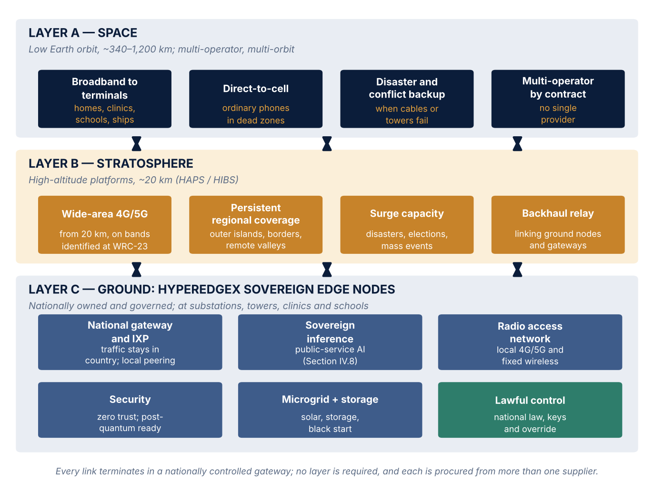
Vision 2100 reference architecture (PROPOSAL; Part IV). No operator, manufacturer or government has agreed to take part.

The five flagship pilots
ILLUSTRATIVE Five small, host-requested pilots test the system at its weakest joints. Hosts are described as archetypes; no country has been approached for, or has agreed to, any pilot. All figures are planning assumptions; no funding is committed.
TABLE ES-2 The five flagship pilots and their planning budgets (ILLUSTRATIVE; no funding committed; Parts IV, V, VI, IX, X and XII)
Pilot and the question it answers | First-year preparation (Nov 2026–Oct 2027) | Initial implementation | Long-term capital (only if gates pass)
P1 Sovereign Digital Nation — can a small state run its core digital services under national control? | $1.0–3.0m | $20–65m over ~4.5 years | $0.3–1.3bn (15–20 states)
P2 Clean Power and Compute Corridor — can anchor loads lower the cost of capital and reach households first? | $1.5–4.0m | $15–40m studies; phase-one construction $0.5–2.0bn, project-financed | $1–10bn (2–5 corridors)
P3 Prevention Early-Warning — can earlier warning produce earlier diplomacy? | $1.0–2.0m | $20–50m over five years | $0.06–0.3bn extension
P4 Minerals-to-Industry — can a producer move one step down the value chain, with consent? | $1.0–3.0m | $10–25m studies; first plant $0.3–1.2bn | $0.6–4.8bn (2–4 plants)
P5 Results Ledger — can public money be followed to a verified result? | $1.5–3.0m | $8–20m over three years | $0.04–0.2bn extension
Secretariat and initiative core | $4–8m per year | — | —

Source: canonical planning ranges in Parts IV, V, VI, IX, X and XII. First-year total: $10–23 million. FOUND horizon (2026–2030): about $120–300 million excluding P2 construction (about $0.6–2.3 billion including it). PROVE (2031–2040): about $2–17 billion, mostly national, development-bank and private capital.
At Gate 0, in October 2027, each pilot must show a written host request, a completed feasibility and ethics review, a financing path for at least 60 percent of first-phase cost and an agreed evaluation design. The Vision 2100 Steering Board then decides to proceed, redesign or stop; a pilot without a host request is recorded as on hold (Parts XII and XIII).

The road from 2026 to 2100
The century is divided into five horizons, each ending at a public decision gate. The horizons are a sequence of conditional commitments, not a forecast.
TABLE ES-3 Five horizons and their decision gates (Vision 2100 proposal; Part XII)
Horizon | Objective | Decision gate
FOUND 2026–2030 | Govern the initiative; build evidence and a coalition of voluntary hosts; take all five pilots through feasibility | Gate 1, December 2030: at least three pilots operating with hosts still requesting them; measurable gains; no unremedied rights, safety or integrity finding
PROVE 2031–2040 | Demonstrate at national and regional scale; replicate in 10–20 volunteer states; stop what fails | Gate 2, 2040: outcomes beat baselines in at least 10 states; costs within 25 percent of plan or explained
CONNECT 2041–2060 | Interconnect proven systems through voluntary agreements; make prevention the default | Gate 3, 2060: regional interoperability; public-trust thresholds met
TRANSFORM 2061–2080 | Clean firm power and sovereign compute as ordinary utilities; preventable maternal and child deaths near zero | Gate 4, 2080: institutions renew themselves; gains held for at least 10 years
SUSTAIN 2081–2100 | Preserve gains; adapt institutions; maintain accountability | Sunset on 31 December 2100 unless renewed

FIGURE ES-3
Vision 2100 roadmap, 2026–2100, by horizon and domain
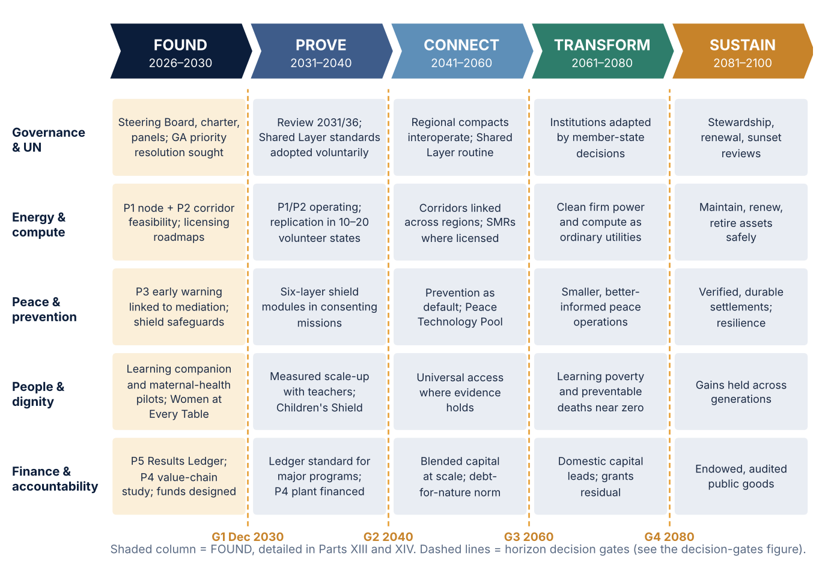
ILLUSTRATIVE — planning framework developed for Vision 2100 (Part XII); subject to five-year reviews and decision gates.

The first year
Vision 2100 proposes the following sequence for the first year (Part XIII).
- First 30 days (to December 2026). Publish the book with its attribution key and conflict-of-interest disclosure; seat an interim steering group of five to seven people, a majority unaffiliated with A113 Partners; open the evidence register to expert challenge; begin a listening round with UN regional groups and regional organizations.
- By 90 days (end of January 2027). Publish a draft charter, conflict-of-interest code and procurement-neutrality rule for comment; establish baselines for every scorecard indicator; prototype the Results Ledger on public budget data.
- By 180 days (end of April 2027). Adopt the charter and seat the Steering Board and four independent panels; seek letters of intent from prospective hosts, limited to feasibility; commission feasibility studies with ethics review from the start.
- By October 2027. Gate 0 decisions on all five pilots, published with reasons; a first annual report.

Governance and safeguards
A framework that asks for accountability must be accountable itself. The Vision 2100 Steering Board — 11 to 13 members from every UN regional group, at least half women, with an independent majority — governs the initiative and decides at each gate whether Vision 2100 continues to support a pilot. A113 Partners holds no more than two seats and no veto. Each pilot is governed by its own Pilot Governance Board, chaired or co-chaired by the host government, and host governments keep their sovereign decision rights at every stage. Four independent panels — technical; human rights and ethics; nuclear safety and nonproliferation; finance and integrity — review the work, and the rights panel can stop an activity where rights findings are not remedied. The secretariat passes to an independent foundation, registered in 2029, with the transfer complete by 2031 (Part XII; Appendix I).
CONFLICT-OF-INTEREST DISCLOSURE
The Principal Strategic and Technical Architect serves as Chief Strategy Officer of American Lithium Energy Corporation, a U.S. battery manufacturer, and founded A113 Partners and A113 Defense, which work on federal technology intelligence and autonomous systems integration. Because pilots P1 and P2 involve energy storage, P4 concerns battery-materials value chains and the shield involves autonomy, A113 Partners and its affiliates will not act as supplier, financier or transaction adviser to any pilot they help design; the Principal Architect is recused from storage and battery-materials specifications; procurement is open and multi-vendor; and storage and autonomy recommendations are to be independently reviewed. The name and concept of the HyperEdgeX edge node originate in commercial work associated with the Principal Architect; in Vision 2100 it is an open reference design that any qualified manufacturer may build to, independently reviewed and openly procured (Appendix I).

Three risks need candor. Financing is most likely to bind, because pilots compete with humanitarian needs for shrinking concessional budgets — hence small first phases. Surveillance and misuse carry the highest impact on trust — hence the rights panel's stop power. Leadership change is near-certain over 74 years — hence gates, a charter and a foundation that do not depend on any person or office (Part XII; Appendix G).
Whether or not Ambassador A-Baki becomes Secretary-General, Vision 2100 is designed to stand. Pilots depend on hosts and financiers, the Results Ledger can start on public data, and the Global Dialogue on AI Governance and the Scientific Panel already exist. Without a supportive Secretary-General, UN-level elements would move more slowly; the whole would not fail (Part XII).

Decisions requested
Nothing in Vision 2100 has been agreed by anyone. Each request is voluntary unless marked as a formal decision, and stands whoever is Secretary-General.
TABLE ES-4 What Vision 2100 asks of each audience (proposals; nothing has been agreed)
Audience | What Vision 2100 asks
Heads of state and government | Consider hosting a pilot (a letter of intent covers feasibility only; consent can be withdrawn at any gate); enact data, identity, cybersecurity and AI laws first
Secretary-General and Secretariat | Within the office's own authority: published criteria for using Article 99; women in senior roles of every mediation team; open cash and mandate data; a Results Ledger pilot for one program
General Assembly (formal decision) | When members choose: recognize Shared Layer standards; extend the Ledger to all mandates
Security Council (formal decision) | Non-lethal shield capabilities in at least one mandate, with host consent
Development banks, IMF and sovereign funds | Complete capital-adequacy reforms; co-design project preparation and guarantees; co-invest in bankable assets on commercial terms
Industry and technology | Frontier-model access on sovereign terms; open standards; no lock-in
Satellite and telecommunications operators | Service for schools, clinics and emergency services on operator-neutral sovereignty conditions: national gateways, two independent paths, continuity of service, universal-service pricing
Universities and civil society | Independent evaluation; peer review of baselines; seats on oversight bodies

Measuring success
ILLUSTRATIVE The headline indicators below come from the master scorecard. The "Agreed international target" column shows the SDG or other agreed commitment where one exists. The 2030–2100 columns are Vision 2100 planning milestones; they do not replace agreed commitments.
TABLE ES-5 Headline indicators: baselines, agreed targets and Vision 2100 planning milestones (ILLUSTRATIVE milestones; Part XII and Appendix H)
Indicator (owner) | Baseline (value, year, source) | Agreed international target | 2030 | 2040 | 2060 | 2100
People without electricity (national governments) | 655m, 2024, Tracking SDG7 2026 | SDG 7.1: universal access by 2030 | ≤400m* | ≤50m | 0 | 0
Chronic hunger (FAO; national governments) | 645m, 2025, FAO SOFI 2026 | SDG 2.1: end hunger by 2030 | ≤500m* | ≤250m | ≤100m | <1% of people
Under-five deaths per year (ministries; UNICEF) | 4.9m, 2024, UN IGME (revised method) | SDG 3.2: ≤25 per 1,000 live births in every country by 2030 | ≤4.0m* | ≤2.5m | ≤1.2m | ≤0.5m
State-based armed conflicts (UCDP; DPPA) | 65, 2025, UCDP | — | ≤55 | ≤40 | ≤25 | ≤10
Women in senior roles of UN-convened mediation teams (Secretary-General; DPPA) | To be established by DPPA, 2027 | — | ≥one-third | Parity (≥50%) | Parity | Parity
Results Ledger coverage (UN Secretariat; governments) | 0 programs, 2026 | — | ≥1 UN and ≥1 national program by 2028 | Majority of Secretariat programme budget | All | All, audited
People offline (national governments; ITU) | 2.2bn, 2025, ITU | — | <1.5bn | <0.5bn | Near zero | 0

Source: Part XII master scorecard and Appendix H. *The 2030 milestone is less ambitious than the agreed international target. It is a planning floor for Vision 2100's own monitoring and does not revise the SDG commitment, which stands.
Two consecutive off-track annual reports trigger a redesign plan within twelve months; an off-track result at a gate holds related funding; and a rights, safety or integrity breach stops the activity, with the reasons published. Indicators moving the wrong way are published too (Part XII).

How the book was verified
Every factual claim in the book was checked against a primary source wherever one could be reached — UN bodies, international agencies, development banks, governments and peer-reviewed research. Of the 59 claims marked for priority verification, 29 were confirmed at a primary source, 27 are carried with the secondary source on which they rest named in the text, two were removed, and one remains flagged in the text pending confirmation. Every statement attributed to Ambassador A-Baki was checked against the UN transcript of her 20 August 2026 dialogue. The full method, verification register and 436-entry bibliography are in Appendices A to C of the book, and readers are invited to challenge any claim.

Principal sources
- UN General Assembly, interactive dialogue with Ivonne A-Baki, 20 August 2026 (UN Web TV machine transcript). https://transcripts.un.org/en/asset/k16/k166orx01x
- Uppsala University, "UCDP: record number of conflicts between states," 9 June 2026. https://www.uu.se/en/press/press-releases/2026/2026-06-09-ucdp-record-number-of-conflicts-between-states
- SIPRI, "Global military spending surges," April 2026. https://www.sipri.org/media/press-release/2026/global-military-spending-surges
- UNHCR, Global Trends: Forced Displacement in 2025, June 2026. https://www.unhcr.org/sites/default/files/2026-06/global-trends-report-2025.pdf
- SEforALL and SDG7 custodian agencies, Tracking SDG 7: The Energy Progress Report 2026, July 2026. https://www.seforall.org/system/files/2026-07/SEforALL%20Tracking%20SDG7%20-%20The%20Energy%20Progress%20Report%202026_Executive%20Version_22Jul2026-2.pdf
- FAO, The State of Food Security and Nutrition in the World 2026, as reported by IFPRI Food Security Portal, July 2026. https://www.foodsecurityportal.org/node/3932
- WHO and UN IGME, Levels and Trends in Child Mortality, 2025 report, 18 March 2026. https://www.who.int/news/item/18-03-2026-progress-in-reducing-child-deaths-slows-as-4.9-million-children-die-before-age-five
- UNCTAD, A World of Debt 2026 (OSG/INF/2026/11). https://unctad.org/system/files/official-document/osginf2026d11_en.pdf
- ITU, Facts and Figures 2025, 15 October 2025. https://www.itu.int/itu-d/reports/statistics/2025/10/15/ff25-foreword
- International Energy Agency, Energy and AI, April 2025, as reported by Scientific American, 10 April 2025. https://scientificamerican.com/article/ai-will-drive-doubling-of-data-center-energy-demand-by-2030
- UN News, "General Assembly approves $3.45 billion UN regular budget for 2026," 30 December 2025. https://news.un.org/en/story/2025/12/1166685
- United Nations, Pact for the Future (A/RES/79/1), 22 September 2024. https://www.un.org/pact-for-the-future/en/node/57

Vision 2100 — A Blueprint for Humanity. First edition. A113 Partners, Dallas, Texas, November 2026. © 2026 A113 Partners.

